*LAB # 06*

structural PATTERNS: com posite PATTERN

# *OBJECTIVE:*

*Understand structural design patterns: Composite Pattern.*

***SINGLETON PATTERN:***

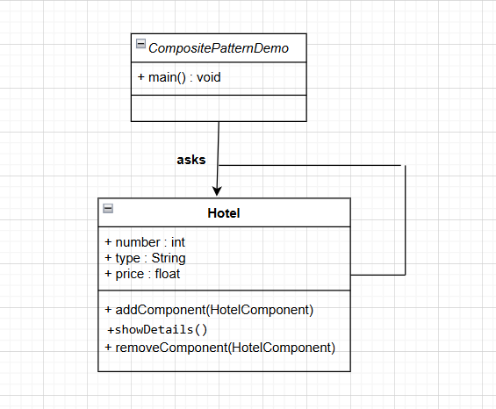

***JAVA CODE:***

### ***Step 1: Create HotelComponent (interface):***

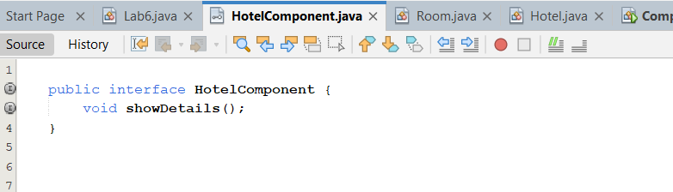

***Step 2: Create Room***

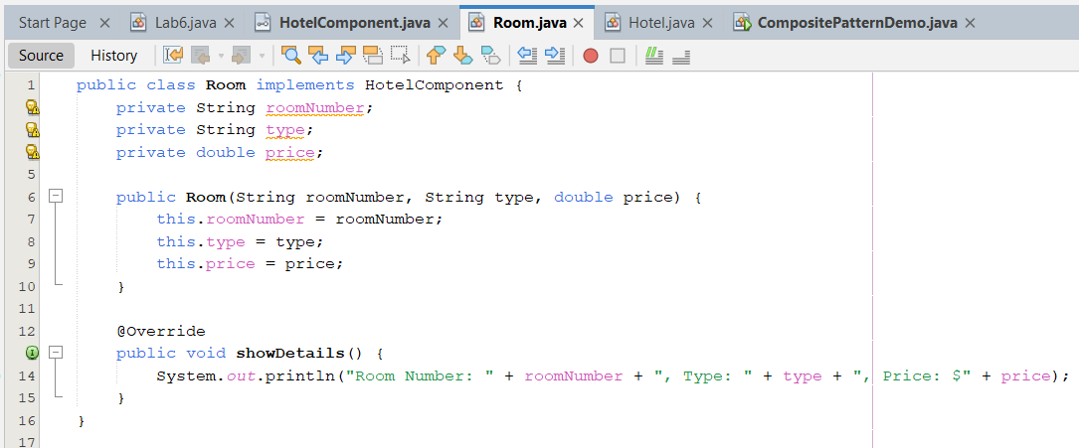

***Step 3: Create Hotel (Composite Class)***

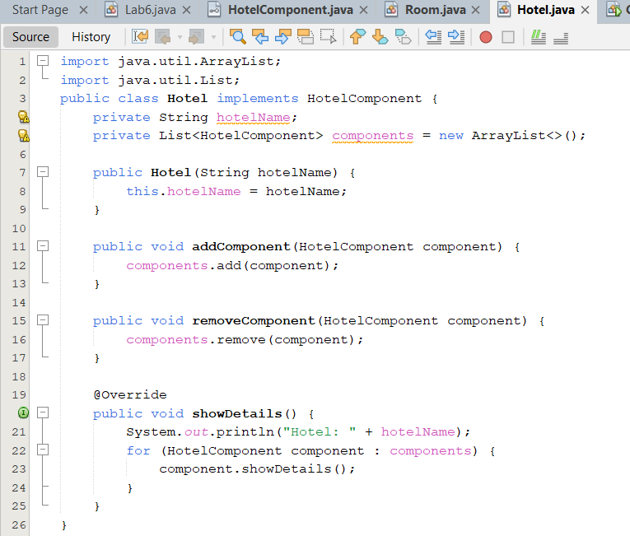

***Step 4: Create CompositePatternDemo***

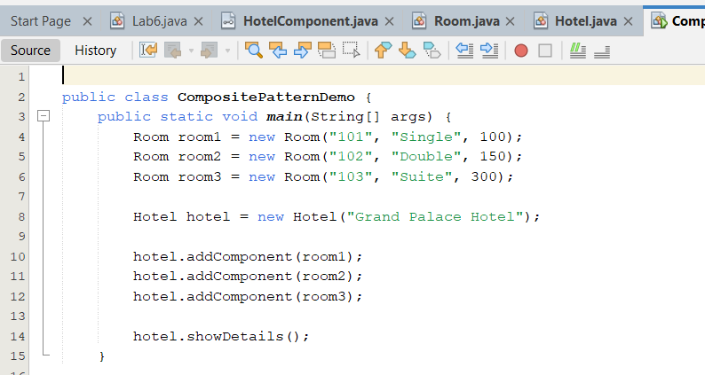

***OUTPUT:***

